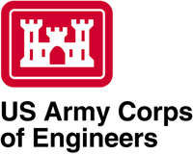

**Reach A Levee**

**Morganza to the Gulf of Mexico, LA**

WRDA 2007 WRRDA 2014

**New Orleans District**

**Mississippi River and Tributaries, Construction (FRM)**

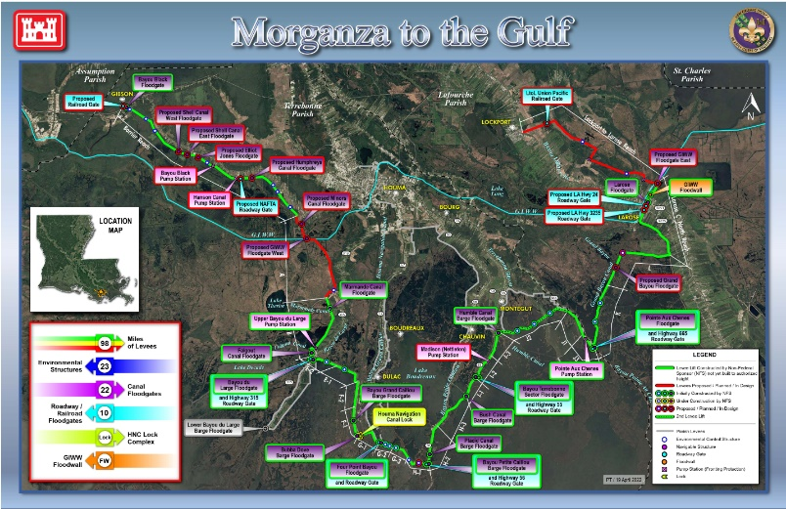

**Project Location:** The Morganza to the Gulf of Mexico, Louisiana (MTG) project is in coastal Louisiana approximately 60 miles southwest of New Orleans and includes portions of Terrebonne and Lafourche parishes. The updated plan described in the 2013 Final Post Authorization Change (PAC) Report and the 2021 Engineering Documentation Report (EDR) is bounded by US Hwy 90 near the town of Gibson to the west and LA Hwy 1 near Lockport to the east.

**Project Description**: The MTG project is a hurricane and storm damage risk reduction project as part of the Mississippi River and Tributaries (MR&T). The project is a 98-mile alignment consisting of earthen levees, floodgates, environmental water control structures, road/railroad gates and fronting protection for existing pump stations. A major project features are two floodgates in the Gulf Intracoastal Waterway (GIWW) and a lock complex on the Houma Navigation Canal (HNC) consisting of a lock and an adjacent sector gate.

The Project was authorized for construction in WRDA 2007, based on 2002 and 2003 reports of the Chief of Engineers, prior to development and implementation of post-Katrina design criteria. Incorporating post-Katrina design criteria into the MTG project has driven project costs more than 20% higher than the cost authorized in WRDA 2007, thereby exceeding the Section 902 Limit and triggering the need for reauthorization. As a result, a PAC Report was completed, and a Chief of Engineers’ Report was signed on 8 July 2013 to seek re-authorization of the project. The project was reauthorized in Water Resources Reform and Development Act (WRRDA) of 2014 to provide 100-year level of risk reduction. Since re-authorization, the project team has progressed the design implementing site adaptive criteria and work that has been completed on the alignment that updated the cost to $6.5B ($10.2B fully funded through the life of the project) as documented in the EDR approved on 15 December 2021. A Project Partnership Agreement (PPA) was signed on 28 December 2021 that limits the federal cost share to $2.5B ($4.9B fully funded). The non-federal sponsors (NFSs) have invested over $1.1B in construction along the alignment, including the HNC Lock Complex.

**Reach A**: The non-Federal sponsors, Terrebonne Levee and Conservation District (TLCD) along with the Coastal Protection and Restoration Authority (CPRA) have constructed over 80 miles of levees in the vicinity of the authorized MTG levee system. However, in the area of Reach A, no levee segments have been constructed. Therefore, the city of Houma and surrounding communities remain vulnerable to flooding, storm surge, and sea level rise. TLCD recognized the urgency of the construction of the Reach A levee as noted in the “Declaration of a State of Emergency—Imminent Threat of Flooding Due to the Reach A Gap in the Morganza to the Gulf Flood Risk Reduction System” that was signed on May 17, 2023.”

Acknowledging the since of urgency, the MTG team took on the charge to advance the greatest amount of risk reduction within Reach A as soon as possible, while minimizing or avoiding impacts to high quality wetland habitats and utilities within the project area. Though the full construction of the Reach A levee will be accomplished over several contracts, the team expedited the design of Contract 1, scheduled to advertise at the end of May. Contract 1 will provide flood risk reduction to vulnerable communities along Bayou Dularge while other important design and impact considerations are developed and assessed. Likewise, the team also expedited the Programmatic Environmental Assessment (PEA) #598 evaluated the potential impacts to the human and natural environment resulting from the construction of Reach A.

Factors for the remaining features of Reach A that would require extensive coordination include the numerous oil and gas pipelines impacted by the levee as well as coordination and consideration of potential impacts to the Mandalay NWR. As the levee and floodgate designs are further developed for future Reach A contracts, consideration of avoidance and minimization of impacts to significant resources will be explored through supplemental NEPA documents.

**Importance:** The MTG project would reduce the risk of flooding due to storm surge to more than 52,000 structures and over 200,000 people in an area. Deterioration of coastal marshes due to saltwater intrusion, land subsidence and the lack of interchanges from the Mississippi River and Tributaries system have steadily increased storm surge inundation over time. Flooding of homes occurred in Lafourche Parish with Hurricane Ida, near the proposed alignment that may be alleviated with the Project.